**1. Introduction**

The Showcase teams are analyzing the "user engagement​" on their platform for a particular month of October 2019. The sole responsibility of this project is to identify and dig patterns of engagement, metrics etc.

**2. Analysis on user engagement**

As showcase has vast platform where multiple users interact share their views, Comments, likes, so they need analyze how end users are interacting with portal and its services.

We need to identify every metrics and user engagements activities like involvement on portal. The following are the features that need to be analyzed

->Exploratory Data Analysis

* Import Data

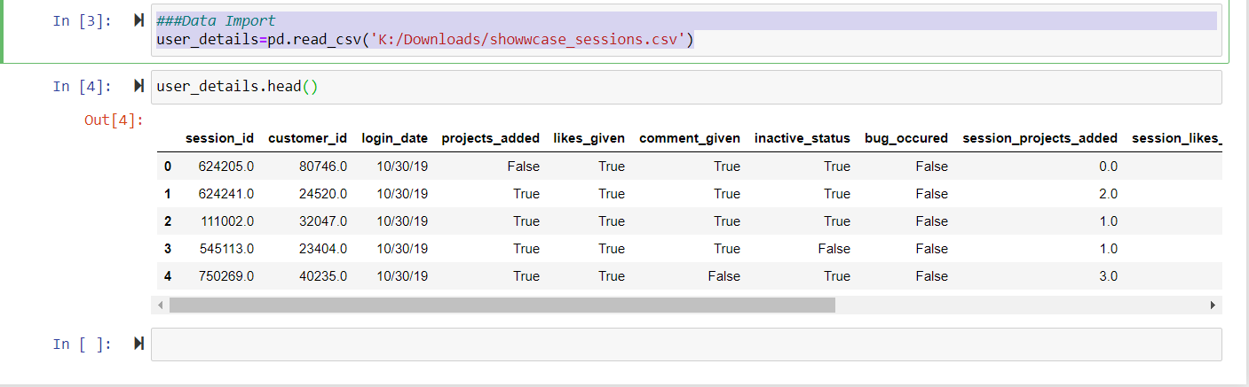

* Data Cleaning

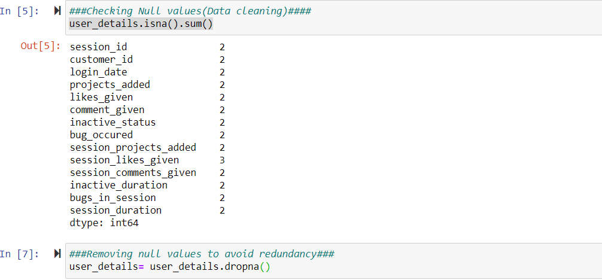

* Replacing Boolean value with 0/1

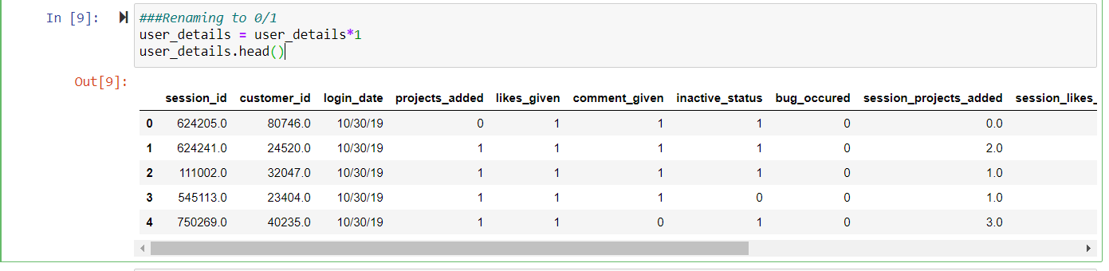

->Data visualization

For user engagement analysis, visualization was performed on Tableau.

1. **Login time/user**

It is the time the user is login on portal.

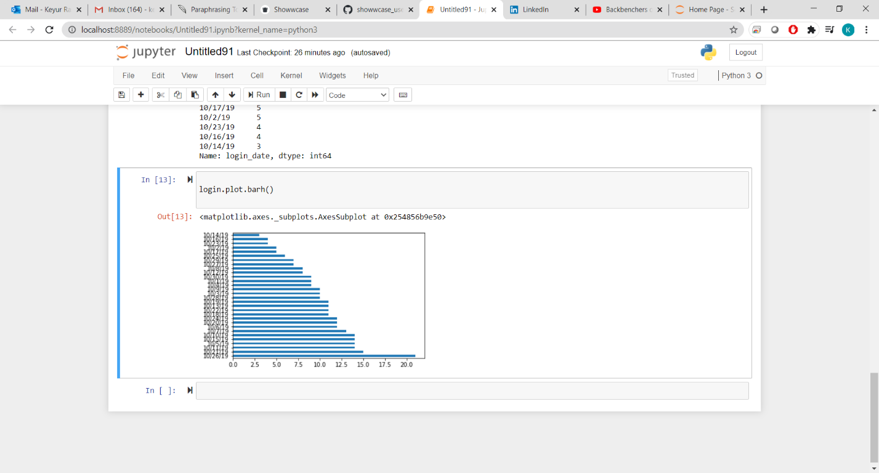

1. **Average Active Time/user**

We have to identify the active time the user spend on portal by using session duration. As per below graph 24th October the maximum session is generated by user. It might be the weekend or any public holiday.

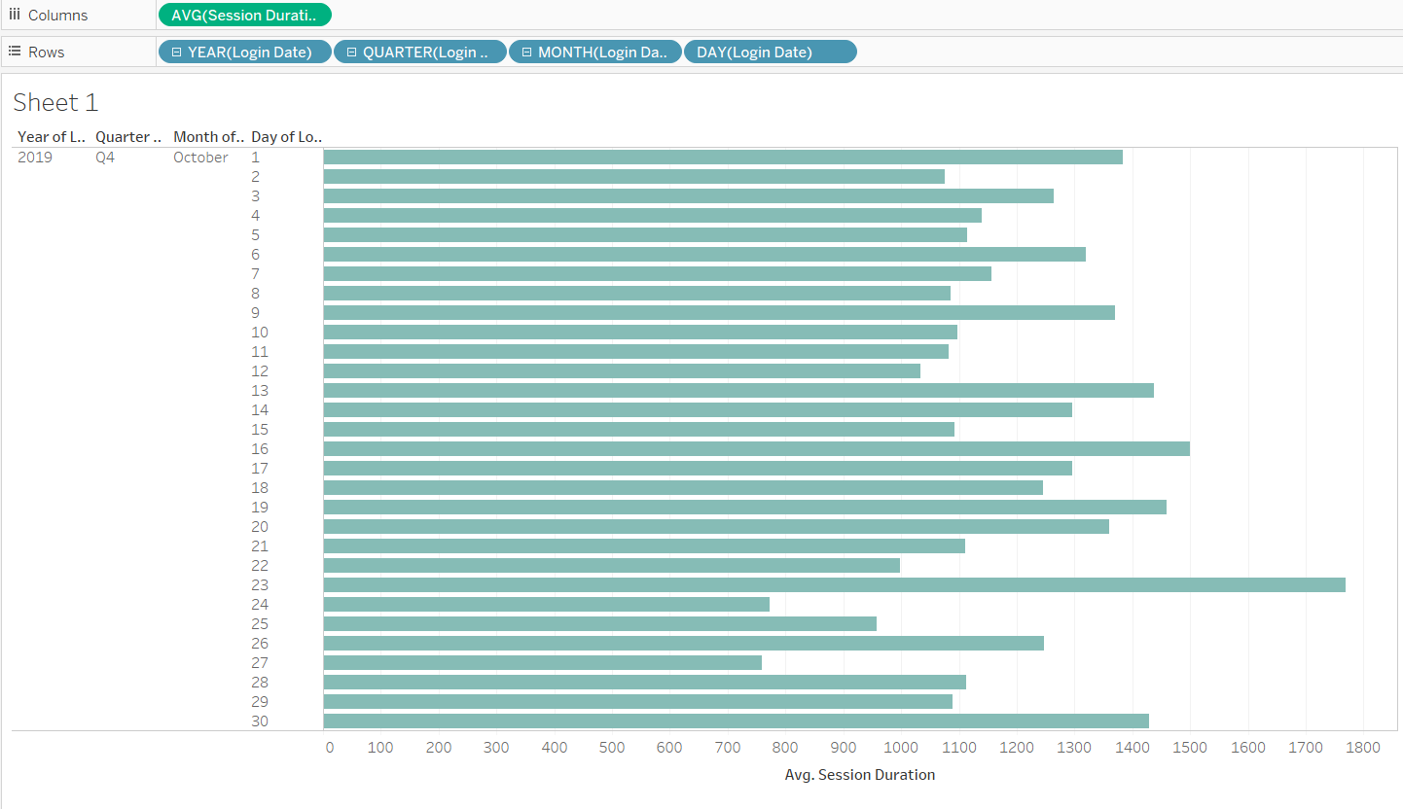

1. Average user engagement by likes, Comments or Adding Projects

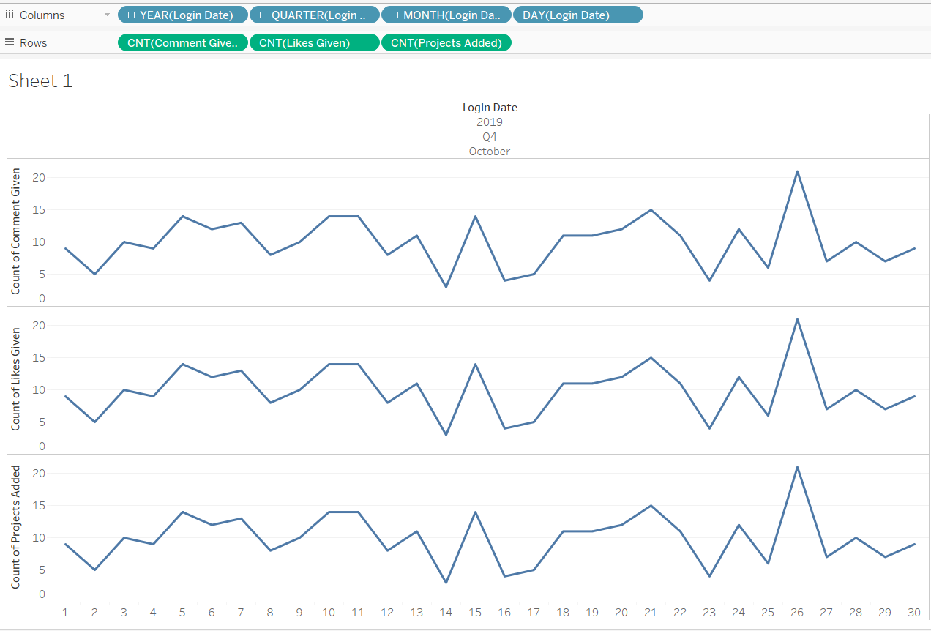

As per above graph, it can be seen that on 26th October there was peak of users on portal for all the likes, comment, Project.

1. **Top 10 customer id spent on likes, comments, project**

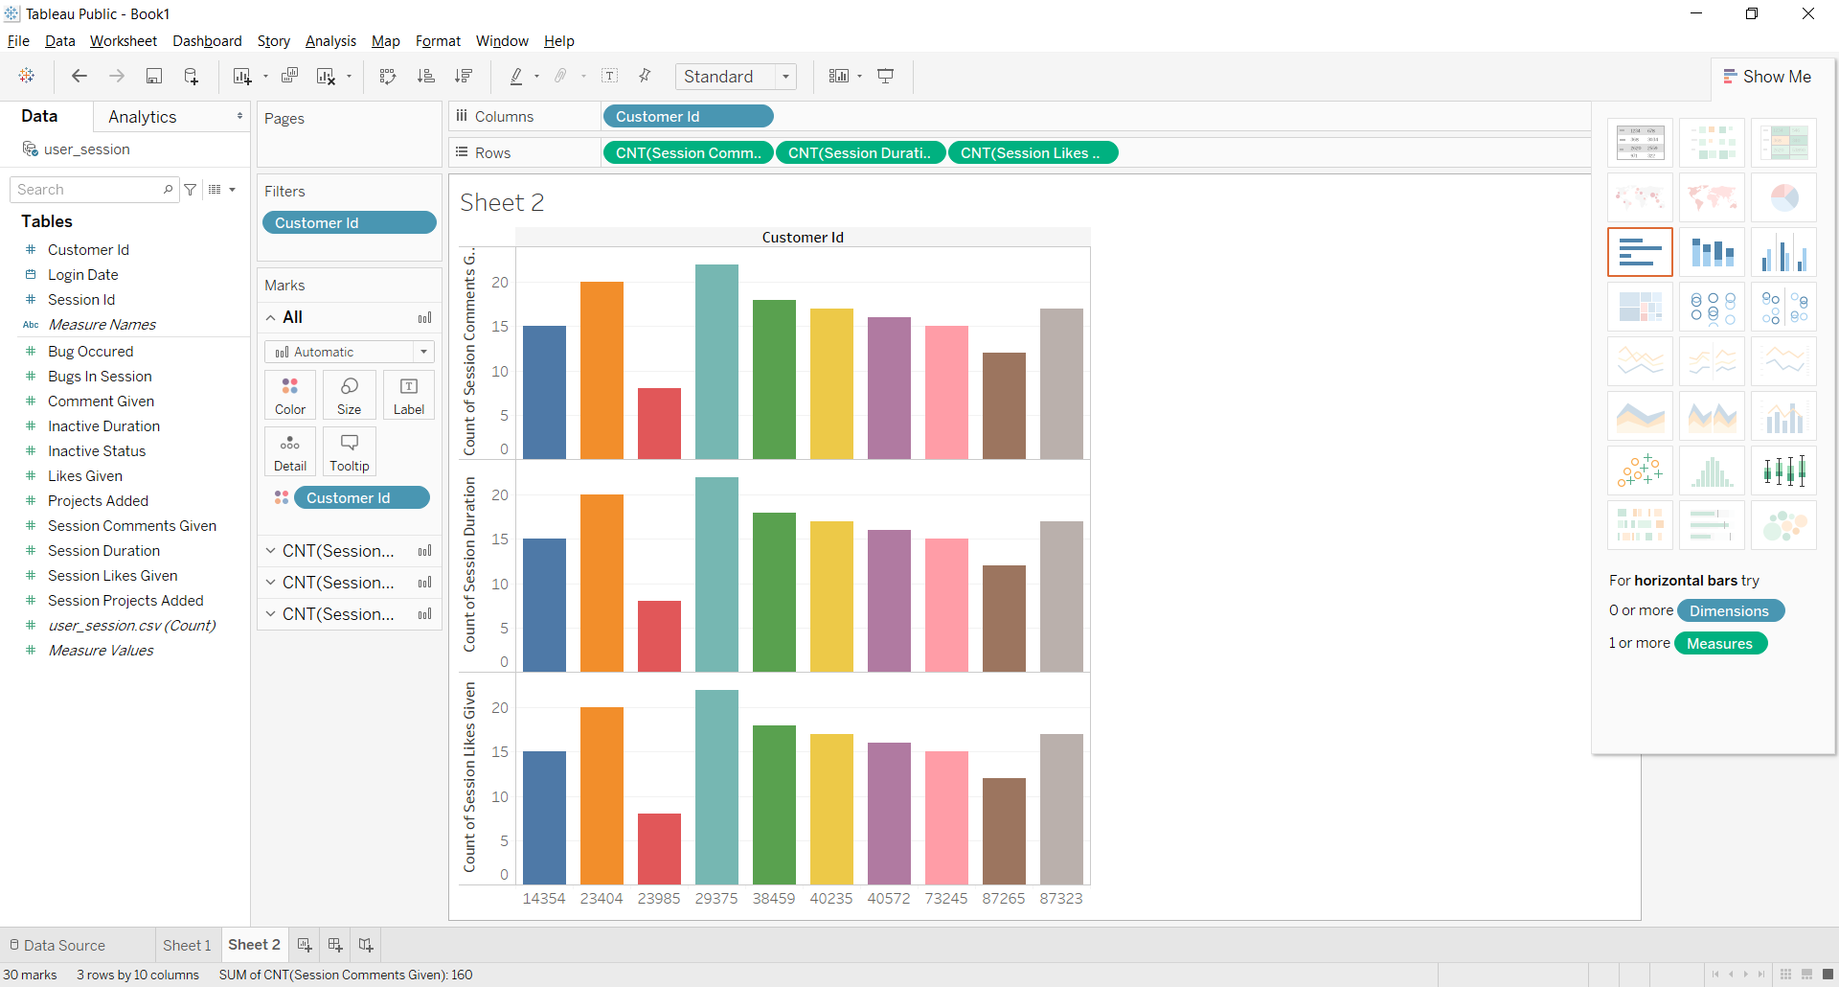

1. Average bugs occurred and session created

Maximum bugs occurred on 8th October and also bug session increase

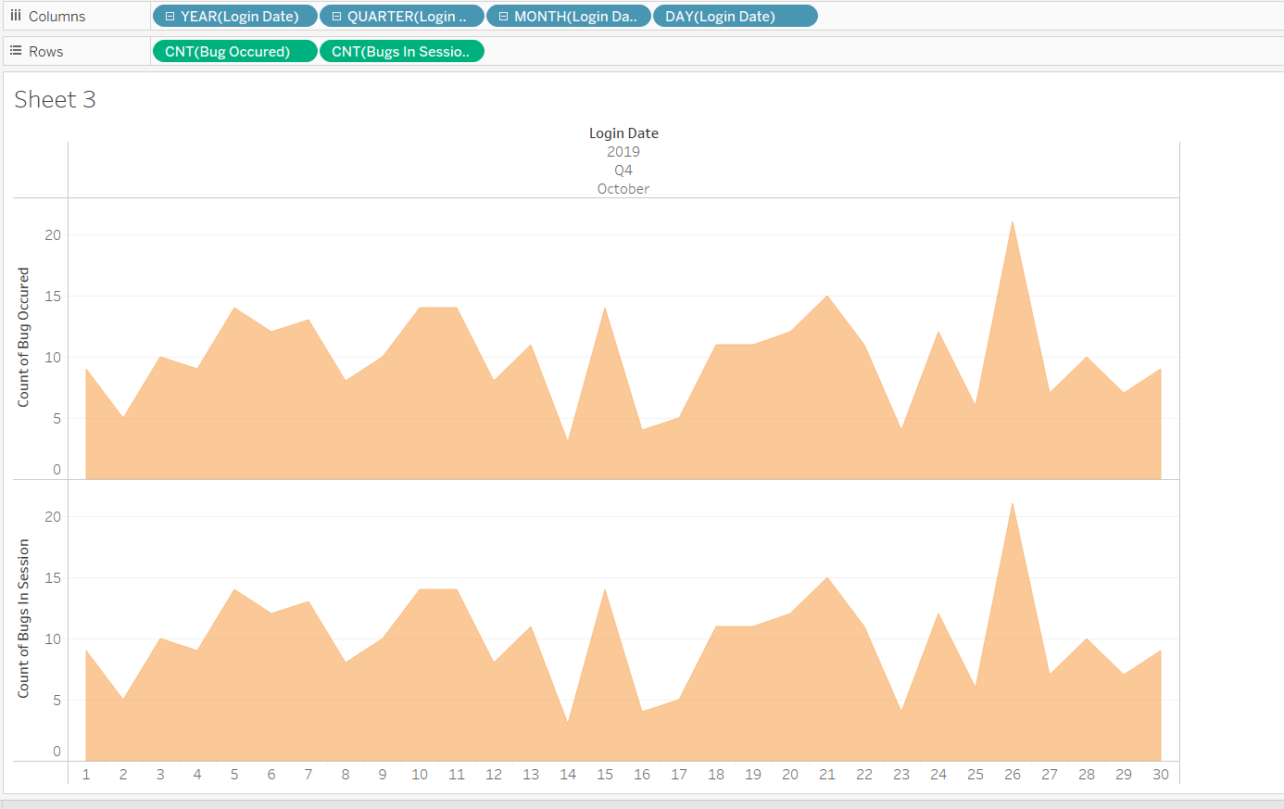

There is no clear connection between each feature, excluding the active time and length of the session

**3. Conclusion**

1. There were a lot of likes, comments, and projects posted on 10/24, which we determined happen to be Saturday.
2. No linear relationship or other association is given between the active times and likes / comments.
3. Furthermore, I will do more research on the relationship between inactive time versus the three metrics of user interaction I use in my model.